Ex. No. 1 | JAVA LOOPS
YouTube Link
Date of Exercise | DD.MM.YYYY

Aim
To demonstrate and understand the implementation of various looping constructs (for, while, do-while) in Java for executing blocks of code repeatedly.

Description
Loops in Java are control flow statements used to execute a block of code multiple times based on a specified condition. They are fundamental for automating repetitive tasks, iterating over collections, and processing data sequentially. The primary types of loops include: 1. **`for` loop**: Ideal when the number of iterations is known in advance. It consists of initialization, a termination condition, and an increment/decrement statement. 2. **`while` loop**: Used when the number of iterations is not known beforehand, and the loop continues as long as a specified boolean condition remains true. The condition is checked before each iteration. 3. **`do-while` loop**: Similar to the `while` loop, but guarantees that the loop body executes at least once before the condition is evaluated. The condition is checked after each iteration. These loops enable efficient and structured program flow for tasks requiring repetition.

Program
public class LoopExamples {
public static void main(String[] args) {
System.out.println("--- Demonstrating for loop ---");
// For loop: Executes a block of code a specific number of times.
// Prints numbers from 1 to 5
for (int i = 1; i <= 5; i++) {
System.out.println("For loop iteration: " + i);
}
System.out.println(); // New line for better readability
System.out.println("--- Demonstrating while loop ---");
// While loop: Executes a block of code as long as a condition is true.
// Prints numbers from 1 to 3
int count = 1;
while (count <= 3) {
System.out.println("While loop iteration: " + count);
count++; // Increment the counter
}
System.out.println();
System.out.println("--- Demonstrating do-while loop ---");
// Do-while loop: Executes the block of code at least once,
// then repeats as long as a condition is true.
// Prints numbers from 1 to 2
int x = 1;
do {
System.out.println("Do-while loop iteration: " + x);
x++; // Increment the counter
} while (x <= 2);
System.out.println();
System.out.println("--- Demonstrating enhanced for loop (for-each) ---");
// Enhanced for loop (for-each): Used for iterating over arrays and collections.
String[] fruits = {"Apple", "Banana", "Cherry"};
for (String fruit : fruits) {
System.out.println("Fruit: " + fruit);
}
}
}

Output Screenshot
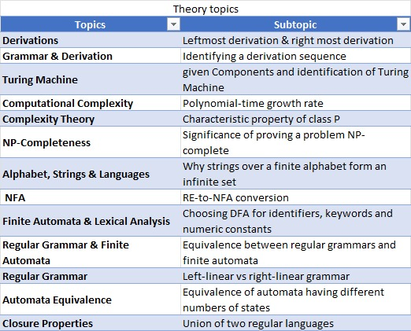

Result
The experiment successfully demonstrated the implementation and behavior of `for`, `while`, `do-while`, and enhanced `for` loops in Java. The objective of understanding how to use these constructs for repetitive execution of code blocks was achieved, confirming their role in controlling program flow.

